**Reema alqahtani**

**Reema.ayedh22@gmail.com**

1- 96ce7430b7eb35d09a1a1d49ab71cf900447506f5ae372880e1af4032245af36

2- 46e617948659acfdae72c96ee383cc7371462fb58577340844b490cfbbc1d524

3- c709ca9bf91d7dfac8c319b62d53c54be4d039611e3f8f29c7d361f3393de73c

4- 18a65a4a2f2a090779878504bd199de8c2b74ddccfd74d213ac91c36d5db0582

5- 39.98.37.102

6- 055672abeb2d5018279ea2ad039bfa752c1f8333c065e3830ba61b17a65f3731

7- https://netflix-tsv[.]com/

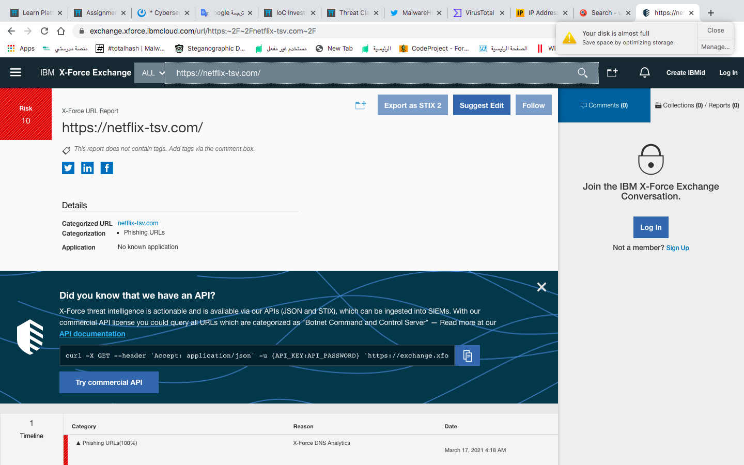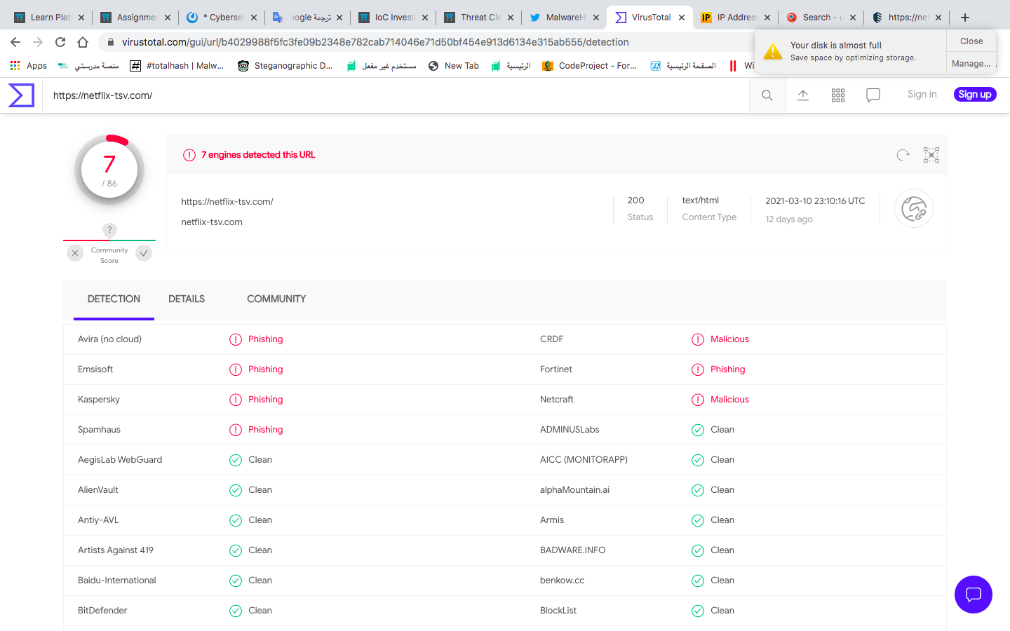

8- 5.181.158.4

9- 83f8b1ec9ba712d543cb6af4662e8d02babb458bd6ab7c514e0f8d46f37bd18f

